My school holidays
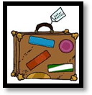

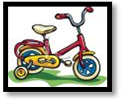
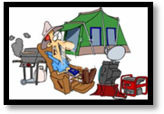
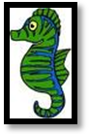
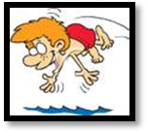
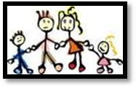
In the school holidays I to interesting places. Sometimes my friends and I out of the city and go . We also visit other towns. My favourite place is Cambrils. It’s by the and we
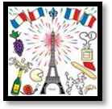
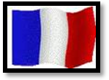
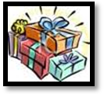
I also go on holiday with my . . We usually spend a week or two in , and I practice my . I always buy for my friends. I usually buy them something unusual.

In the school holidays I travel to interesting places. Sometimes my friends and I cycle out of the city and go camping. We also visit other towns. My favourite place is Cambrils. It’s by the sea and we go swimming.
I also go on holiday with my family. We usually spend a week or two in France, and I practice my French. I always buy presents for my friends. I usually buy them something unusual.

